**Ingress**

* To understand concept of ingress <https://doc.traefik.io/traefik/getting-started/concepts/>
* In k8s we have 3 major objects which will help in ingress (layer 7 loadbalancing)
  + ingress
  + ingressController: This is a third party implementation <https://kubernetes.io/docs/concepts/services-networking/ingress-controllers/>
  + ingressClass
* K8s doesnot have controller for ingress.
* Lets create four simple applications <https://github.com/asquarezone/DockerZone/commit/4c6d947f089ae8cd9581c426a16afe22155e7e7f> for changes done

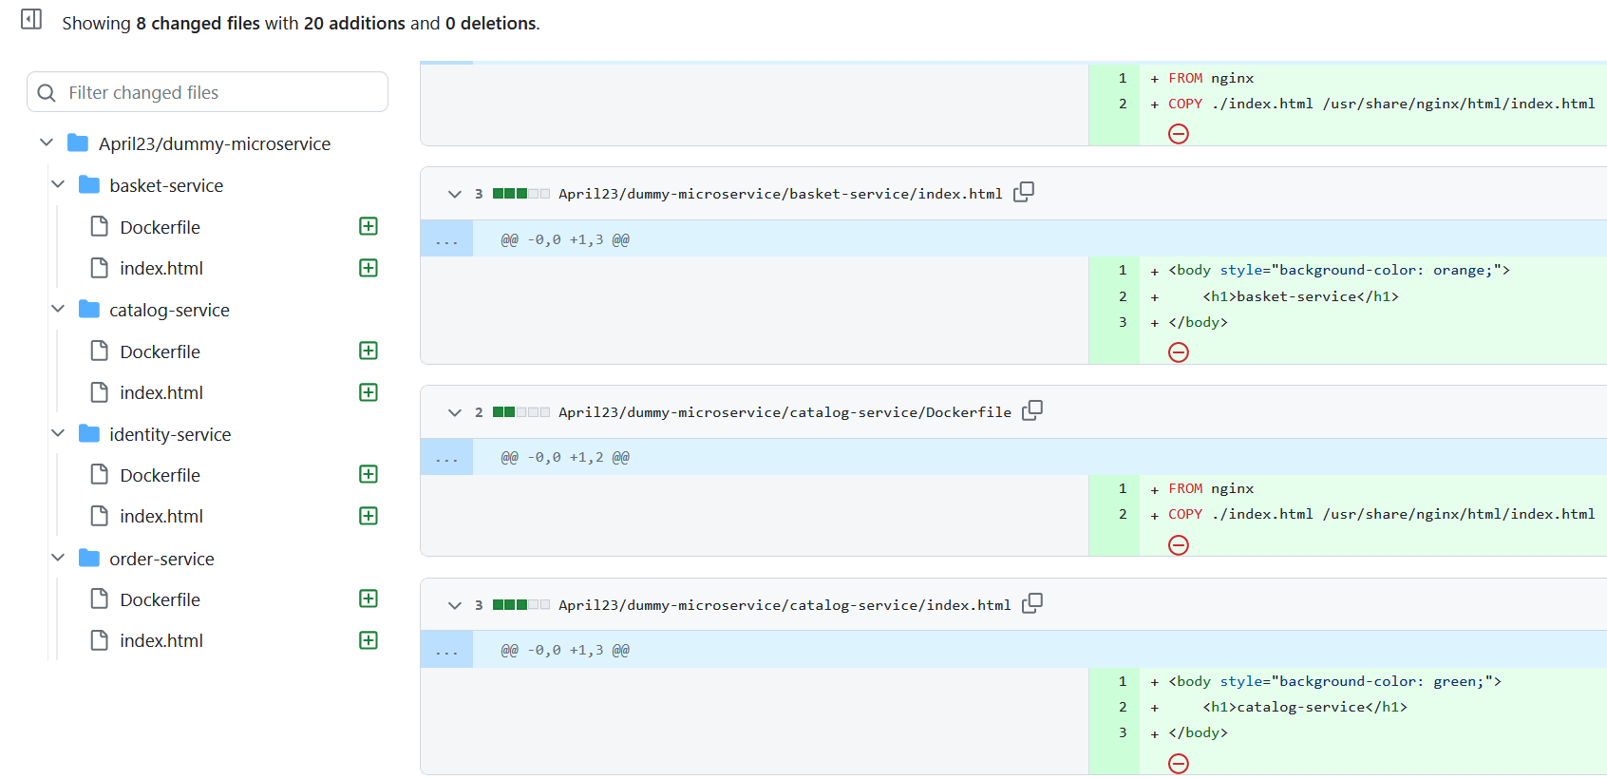

* Create docker image and push them to registry
* For this classroom purpose i will be using nginx-ingress-controller <https://www.nginx.com/products/nginx-ingress-controller/>
* Our implementation:  
  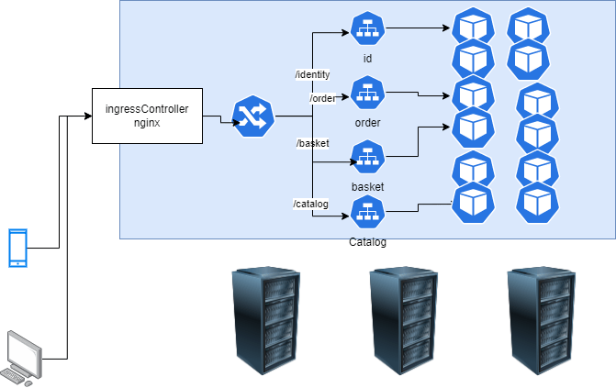
* let’s install nginx-ingress controller using helm

helm repo add nginx-stable https://helm.nginx.com/stable

helm repo update

helm upgrade --install ingress-nginx ingress-nginx \

--repo https://kubernetes.github.io/ingress-nginx \

--namespace ingress-nginx --create-namespace

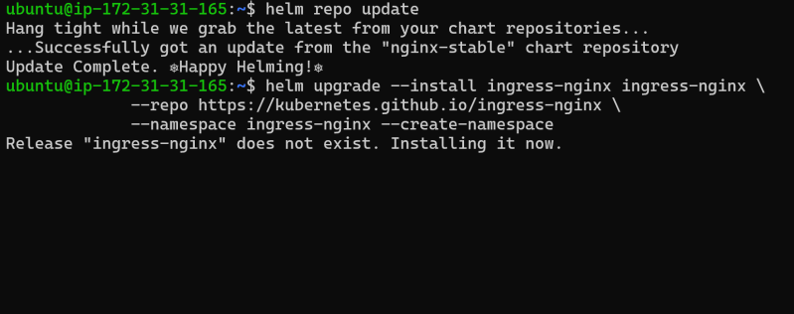  
* After last command we see output which better copy to some notepad  
* Now execute the following command to watch for external ip to nginx ingress controller kubectl --namespace ingress-nginx get services -o wide -w ingress-nginx-controller  
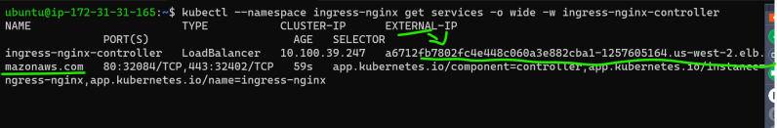  
* Get ingress classes and there should be nginx ingress class from helm chart  
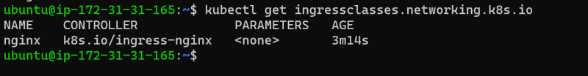  
* lets deploy application and services. [Refer Here](https://github.com/asquarezone/DockerZone/commit/f7d7835ff711499523d049c6ae87f4f2a29b2f26) for the changes  
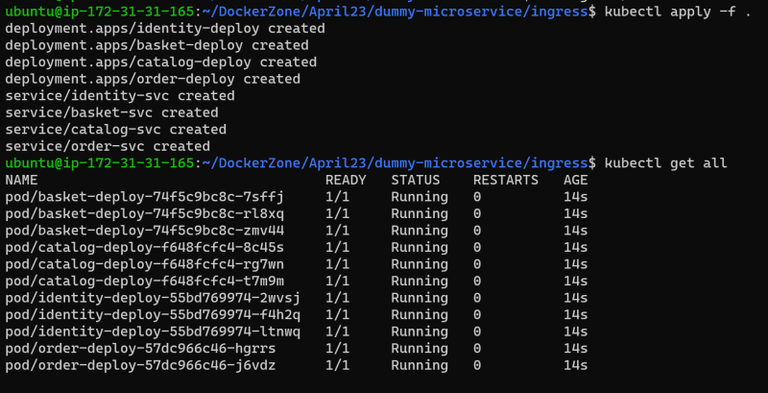  
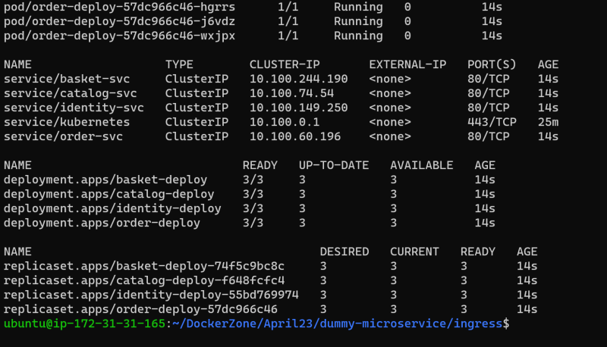

Ref <https://github.com/asquarezone/DockerZone/commit/37705b10210b89f144fcefd0315f9ac91eaa84f4> for the manifest file for ingress

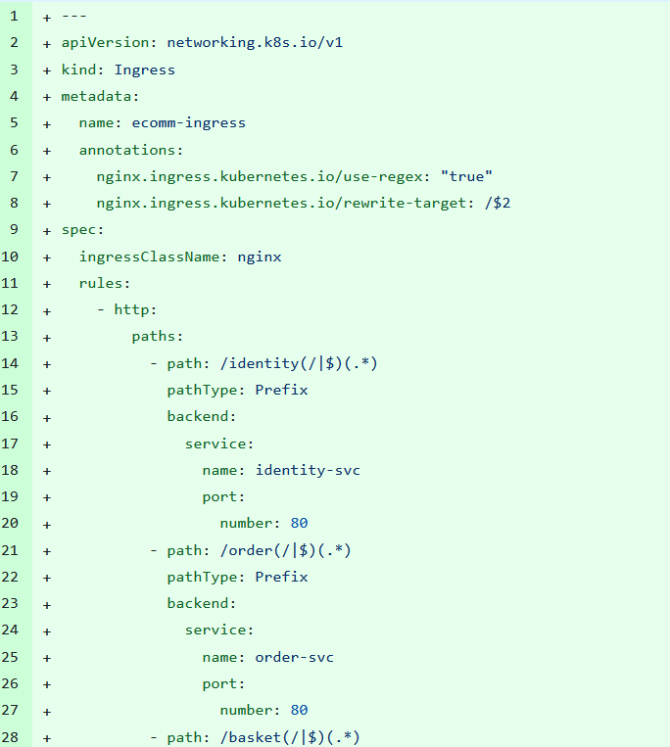

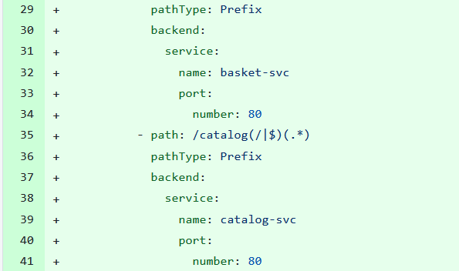

Now create ingress object  
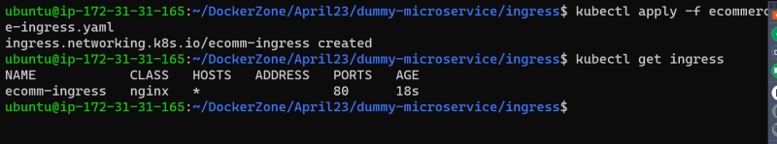  
* Get external ip of ingress controller using kubectl --namespace ingress-nginx get services -o wide -w ingress-nginx-controller  
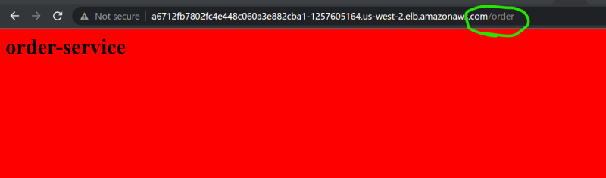  
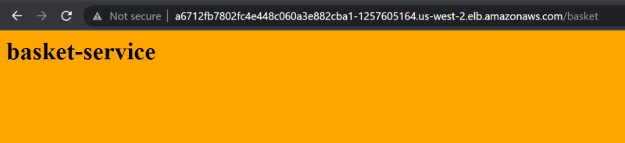  
<https://kubernetes.io/docs/concepts/services-networking/ingress/> for official docs of ingress

**Node autoscaler**

* <https://learn.microsoft.com/en-us/azure/aks/cluster-autoscaler> for aks cluster autoscaler
* <https://docs.aws.amazon.com/eks/latest/userguide/autoscaling.html> for eks cluster autoscaler